

Week 6 - Project Report
By : Kanchan Rai

Topic : Microservices Flight Booking System w/ We Flux

The following document contains the description and explanation of the project Microservices Based FlightBookingSystem made with WebFlux using MongoDB. This project has all the required validations for all end points, exception handling, unit test coverage of. Load testing carried out as well for all endpoints. The database used is MongoDB. And Reactive Programming has been carried out as well.

INDEX

1. Project Over View
1.1 System Architecture
1.2 Eureka Registering
2. JCoco Coverage Report
3. SonarQube Report
4. JMeter Load Testing
4.1 With 20 Threads
4.2 With 50 Threads
4.3 With 100 Threads
5. All API Endpoints Testing & Results

1. Project Overview

This project was a monolithic application with one single db called the “flightBookingSystem” in MongoDB, based on the reactive web flux in spring boot. The project has now been converted to a microservices architecture based project. There are two microservices namely “booking-service” and “flight-service”. These services are connected by a common api-gateway and a configuration server. In between these services proper load balancing has been applied along with the circuit breaker in between to ensure that all services stay up and running. These services have been registered on the netflix eureka server. Along with this apache-kafka message broker technique has also been applied to send notifications whenever a flight is booked or cancelled. Proper load testing using Apache JMeter and JUnit testing has been done.

1.1. System Architecture

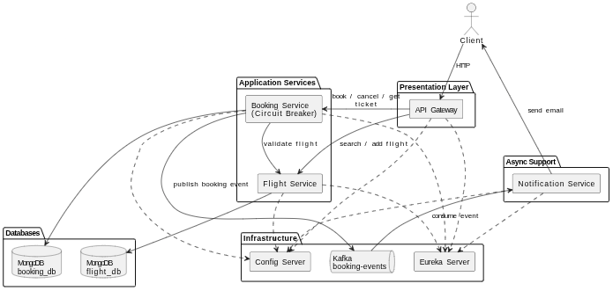

1.2 Eureka Registering

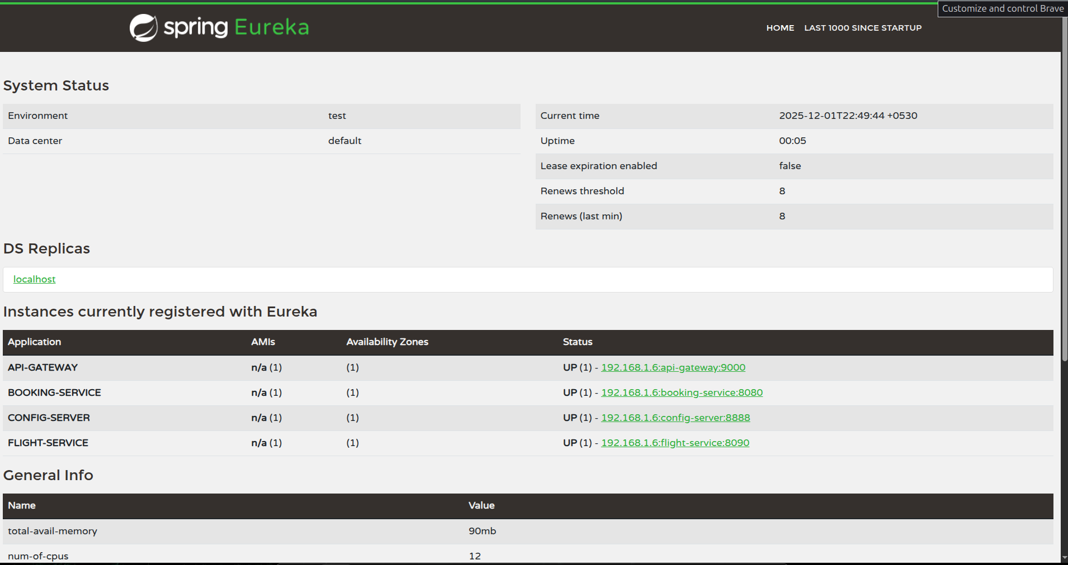

This is the Eureka Server where all four services are successfully registered, namely flight-service, booking-service, config-server,and api-gateway.

This project also implements Message Broker using Apache Kafka which is used whenever a flight is booked or cancelled in the booking service and a mail is sent to the passenger.
Kafka was used with docker the commands are as follows -

docker run -d \
--name kafka \
-p 9092:9092 \
-p 9093:9093 \
-e CLUSTER_ID=$CLUSTER_ID \
-e KAFKA_NODE_ID=1 \
-e KAFKA_PROCESS_ROLES=broker,controller \
-e KAFKA_LISTENERS=PLAINTEXT://0.0.0.0:9092,CONTROLLER://0.0.0.0:9093 \
-e KAFKA_ADVERTISED_LISTENERS=PLAINTEXT://localhost:9092 \
-e KAFKA_CONTROLLER_LISTENER_NAMES=CONTROLLER \
-e KAFKA_CONTROLLER_QUORUM_VOTERS=1@localhost:9093 \
-e KAFKA_OFFSETS_TOPIC_REPLICATION_FACTOR=1 \
-e KAFKA_TRANSACTION_STATE_LOG_REPLICATION_FACTOR=1 \
-e KAFKA_TRANSACTION_STATE_LOG_MIN_ISR=1 \
confluentinc/cp-kafka:7.5.0

2. JCoco Coverage Report -

Coverage Report for FlightService - 96%
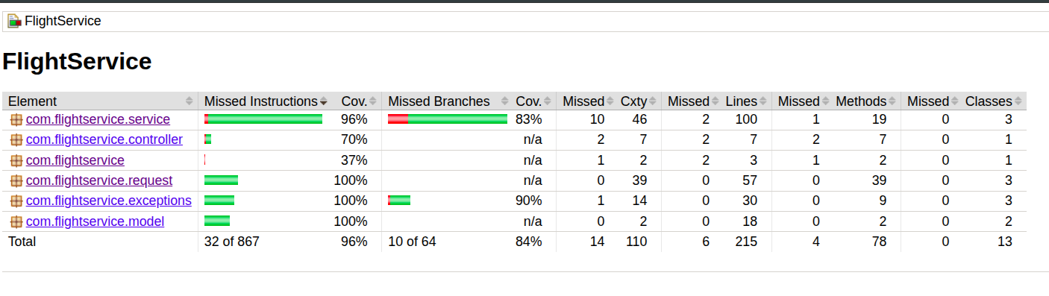

Coverage Report for BookingService - 92%

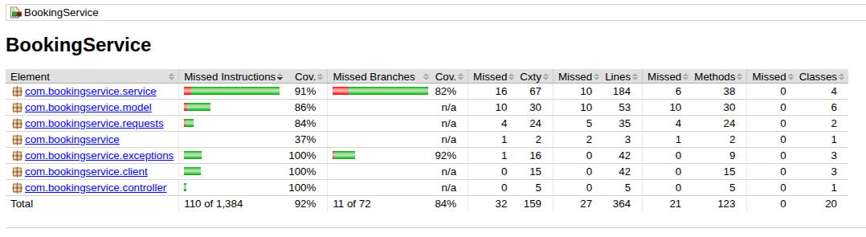

3. SonarQube Report

1. Before Fixing
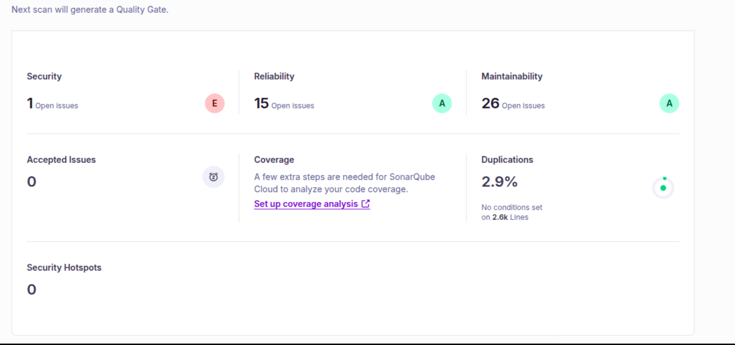

Before fixing the project had 1 security issue, 15 reliability, 26 open issues and 2.9% code duplication.
After fixing everything was reduced to 0.

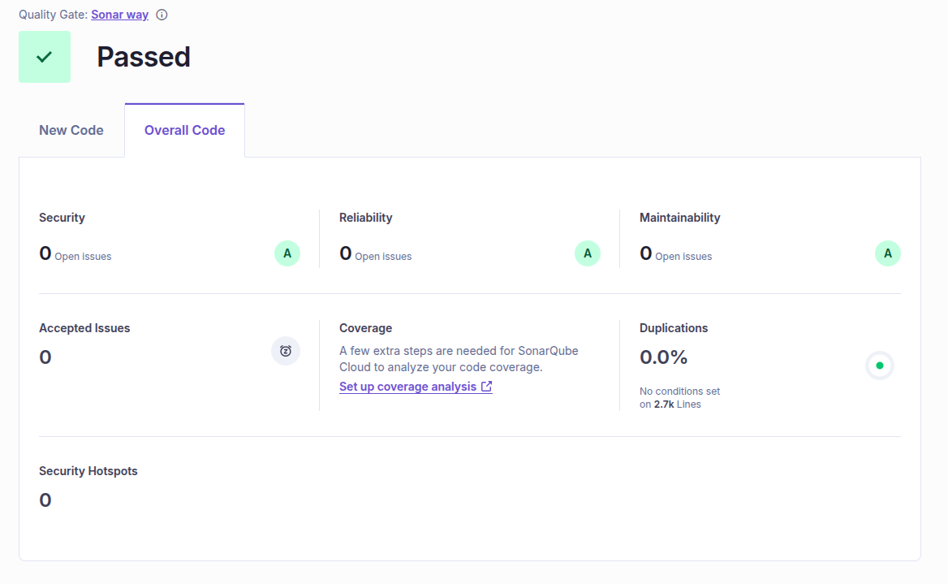

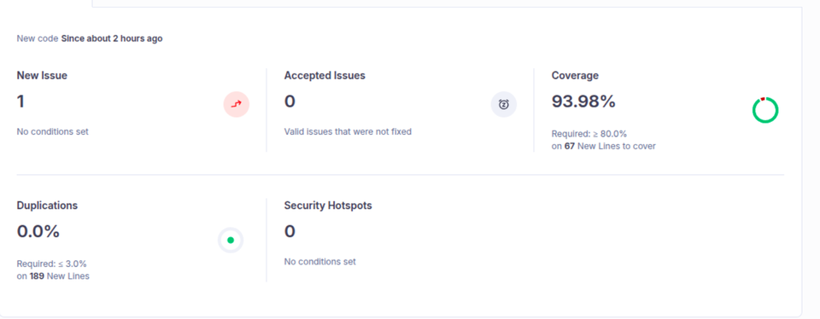

4. JMeter Load Testing

4.1 With 20 Threads

The JMeter testing for 20 threads across the get,post, and delete requests have been carried out successfully through CLI as well as GUI.

Command used and result stored in a csv file -

jmeter -n -t ‘LoadTesting20 .jmx’ -l result20.csv

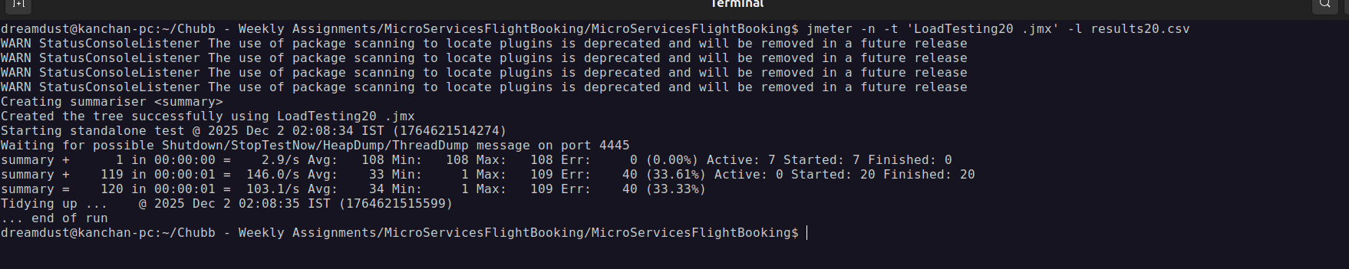

Result CSV-

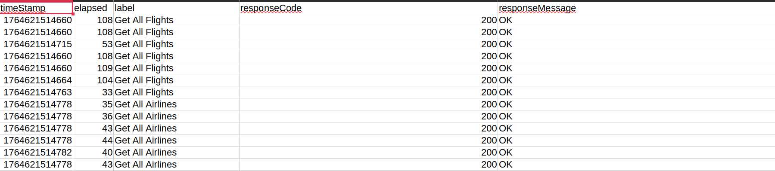

4.2 With 50 Threads

The JMeter testing for 50 threads across the get,post, and delete requests have been carried out successfully through CLI as well as GUI.

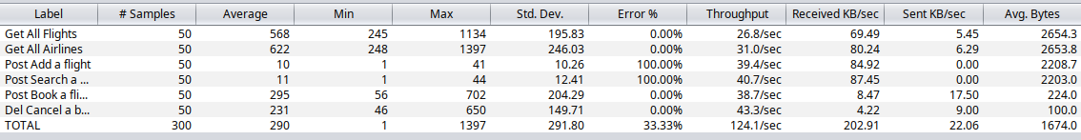

4.3 With 100 Threads

jmeter -n -t ‘LoadTesting100 .jmx’ -l result100.csv

5. API Gateway End Points
API Gateway on port 9000

1. POST Add an airline
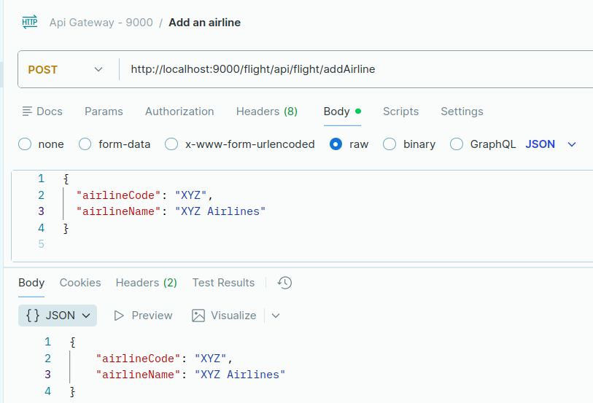

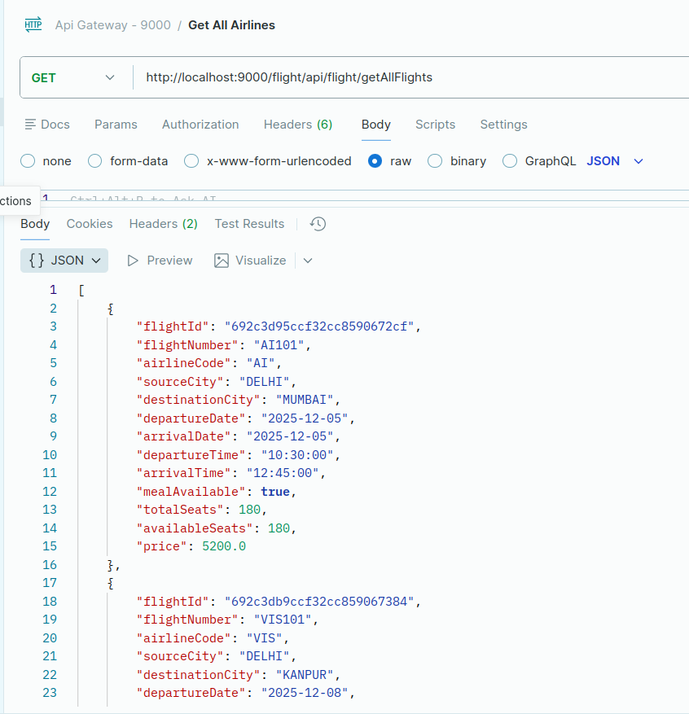
2. GET All Airlines

3. GET Airline by Code
3. POST Search a Flight

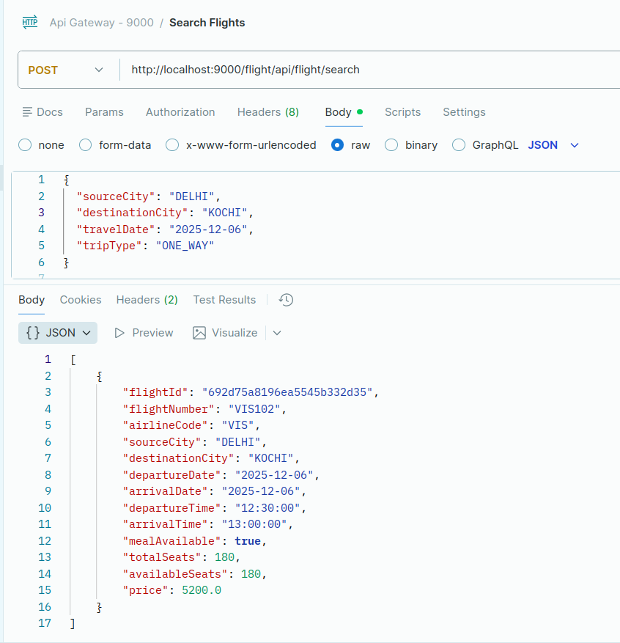

4. POST Add a flight
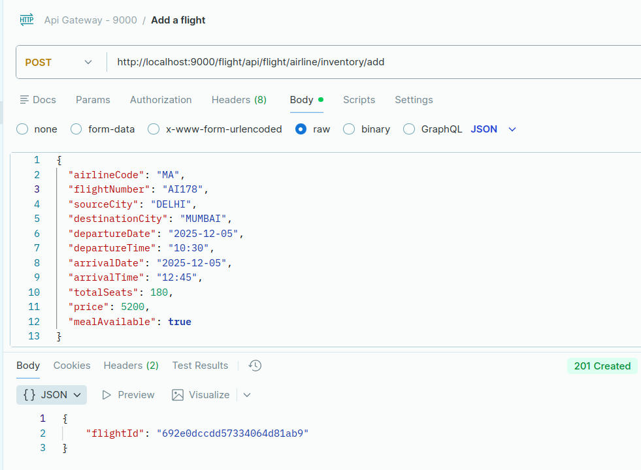

5. DEL Cancel a booking by pnr
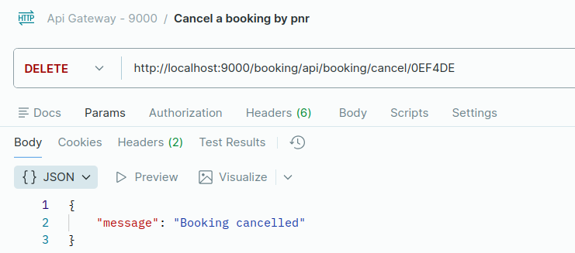

6. GET Ticket by pnr
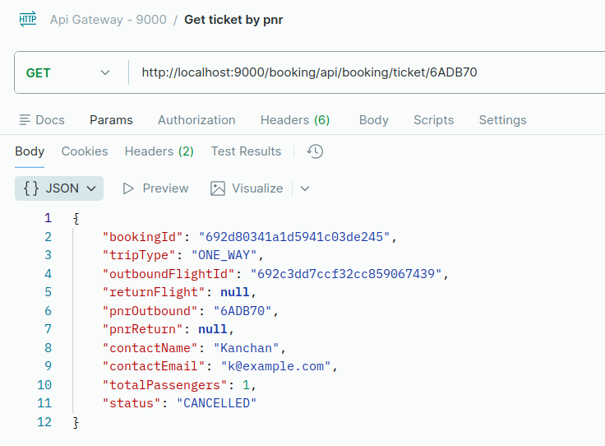

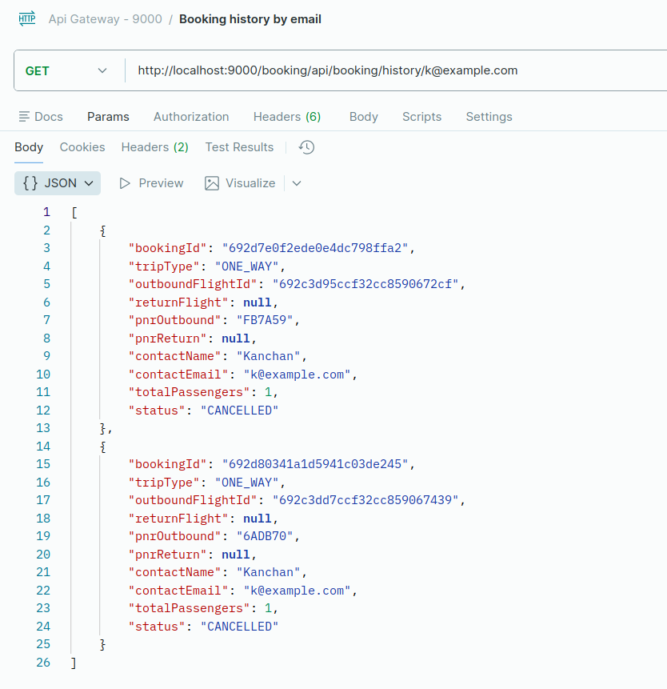
7. GET Booking history by email

8. Service Unavailable when Flight Service is down - Circuit Breaker
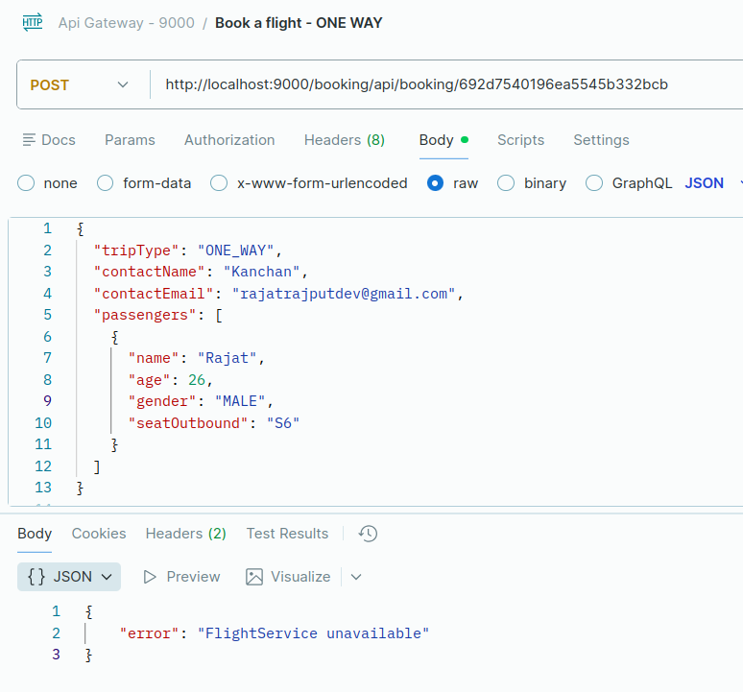

9. SEND Mail when a flight is booked/cancelled through message broker in Apache Kafka
